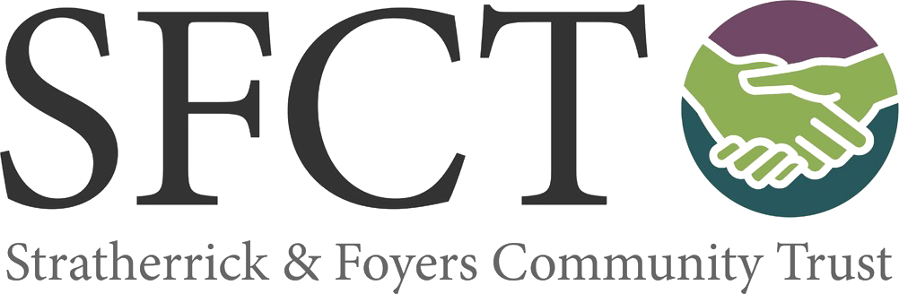

**Pathways group app idea**

The pathways group is an action group of volunteers that is a sub-group of the Trust and formed after the CAP. The group have done some path improvements, an audit of all the local paths and trails and produce walk information for the community via the ‘Walk the walk’ campaign. In 2024, the group started looking into the idea of developing an app that could hold details of all the local paths information along with heritage, nature and local information.

**Progress so far**

The group have conducted the discovery stage of the app development to explore the idea. They held a community engagement day in Feb to show what the app could look like and discuss with the community. They had surveys on the day and would now like to share that survey with the wider community – see link below and paper copies will be available at the Wildside Centre, BCC Hub, the doctor’s surgery and the Foyers shop. Closing date 25th April 2025

**Survey link - https://forms.office.com/e/M23fY3uuDY**

**What is an app?**

An app, which is short for "application," is a type of software that can be installed and run on a computer, tablet, smartphone or other electronic devices. An app most frequently refers to a mobile application or a piece of software that is installed and used on a computer. In this case, it would be an app for a mobile application like a smartphone.

**Costs**

The Community trust has spent £10,800 so for on the discovery phase that has given the group information on costs and a prototype that we could use if the idea was to get community backing to go forward with this idea.

**Development costs –**

App version 1 development cost £55,000 **OR**

VAT (20%) £11,000

**Total £66,000**

App version 2 development Cost £75,000

Augmented Reality Development Cost £7,850

VAT (20%) £16,570

**Total £99,420**

**Basic Yearly running costs –**

Essential Hosting Package - **£1,800 per year ex VAT** (potential to monetise the app to help pay for this)

**Potential funding for the project –**

The group have several funds in mind that we would apply to if they were going to go forward with the full development of the app and hope to keep the cost of the next stage of this project from SFCT to around £15-£30k. Any spend subject to community backing and then the spend approved by our funders and the board. Another option is a sponsor is attracted to cover the cost of the App development.

**Intellectual Property**

All Inventions and Intellectual Property (“IP”), which come as a result of the Project will wholly be owned by Stratherrick and Foyers Community Trust if we were to go forward with this project.